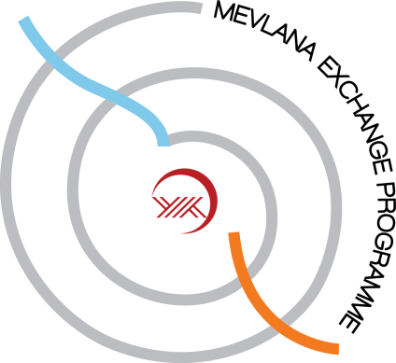
ÖD: Öğrenci Değişimi SE: Student Exchange

Alan kodu  Field code |  | Derece  Degree |  |  |  | Yükseköğretim Kurumu  Higher Education Institution |  | Toplam  Total
Kod  Code | Ad  Field Name | Ön Lisans  Associate Degree | Lisans  Bachelor Degree | Yüksek Lisans  MA | Doktora  PhD | Gönderen  Home Institution | Kabul eden  Host Institution | Öğrenci Sayısı  Student Number | Değişim Süresi (Ay)  Exchange Duration (Month)
16.1 | Physical Education, Sport Science |  | X | X |  | KMU  UPM | UPM  KMU | 10 | 5 months
06.4 | Civil Engineering |  | X | X |  | KMU  UPM | UPM  KMU | 10 | 5 months
06.8 | Computer Engineering |  | X | X |  | KMU  UPM | UPM  KMU | 10 | 5 months
08.2 | Food Engineering |  | X | X |  | KMU  UPM | UPM  KMU | 10 | 5 months
06.2 | Electrical Engineering |  | X | X |  | KMU  UPM | UPM  KMU | 10 | 5 months
11.1 | Mathematics |  | X | X |  | KMU  UPM | UPM  KMU | 10 | 5 months
05.0 | Education, Teacher Training |  | X | X |  | KMU  UPM | UPM  KMU | 10 | 5 months
04.0 | Business Studies, Management Sciences |  | X | X |  | KMU  UPM | UPM  KMU | 10 | 5 months
09.0 | Languages |  | X | X |  | KMU  UPM | UPM  KMU | 10 | 5 months
14.3 | Economics |  | X | X |  | KMU  UPM | UPM  KMU | 10 | 5 months
12.6 | Nursing |  | X | X |  | KMU  UPM | UPM  KMU | 10 | 5 months

ÖEH: Öğretim Elemanı Hareketliliği ASM: Academic Staff Mobility

Alan Kodu  Field Code | Ders Verilen Alan veya Faaliyetler  Field of Teaching or Activities | Öğretim Üyesi Sayısı  Number of Academic Staff | Yükseköğretim Kurumu  Higher Education Institution |  | Dönem Olarak Toplam Süre  Total Duration in Period | Haftalık Ders Saati  Weekly Course Hour
 |  |  | Gönderen  Home Institution | Kabul eden  Host Institution
16.1 | Physical Education, Sport Science | 5 | KMU  UPM | UPM  KMU | 1-3 weeks | 6
06.4 | Civil Engineering | 5 | KMU  UPM | UPM  KMU | 1-3 weeks | 6
06.8 | Computer Engineering | 5 | KMU  UPM | UPM  KMU | 1-3 weeks | 6
08.2 | Food Engineering | 5 | KMU  UPM | UPM  KMU | 1-3 weeks | 6
06.2 | Electrical Engineering | 5 | KMU  UPM | UPM  KMU | 1-3 weeks | 6
11.1 | Mathematics | 5 | KMU  UPM | UPM  KMU | 1-3 weeks | 6
05.0 | Education, Teacher Training | 5 | KMU  UPM | UPM  KMU | 1-3 weeks | 6
04.0 | Business Studies, Management Sciences | 5 | KMU  UPM | UPM  KMU | 1-3 weeks | 6
09.0 | Languages | 5 | KMU  UPM | UPM  KMU | 1-3 weeks | 6
14.3 | Economics | 5 | KMU  UPM | UPM  KMU | 1-3 weeks | 6
12.6 | Nursing | 5 | KMU  UPM | UPM  KMU | 1-3 weeks | 6

